**Sprint 2 Report**

***Sandwich Story***

***Members: Alex Williamson(PO), Chris Hahn, Celine Peña,***

***Davie Truong(SM), David Stewart(SM), Matthew Diep***

**Actions to stop doing:**

We decided that we would like to stop wasting time deciding where we would like to meet. This week, we found ourselves spending an extended amount of time deciding on a place and then switching locations quite a few times for different reasons. We think it would be quite beneficial to our time if we pick one specific place for all of our meetings and stick to that plan.

**Actions to start doing:**

First, we’d like to start being more proactive in taking on roles when problems arise. The agile practice of not being assigned tasks but rather choosing assignments ourselves is fairly new to us all. We’ve found that when it’s more open like this, we just assume our other teammates will take on a role rather than just taking it ourselves. We believe this will greatly improve our efficiency and cut down on the time it takes to complete tasks greatly.

Next, we really would like to start seeking help from outside sources. During sprint 1, we didn’t have too many issues that might have required help from a TA but during sprint 2, we came into a problem that we were unable to solve on our own. Asking for help sooner might have cut down the time spent trying to figure out the issues we were having with the database.

Lastly, we would like to start being more collaborative. Up until now, we have divided our team into back-end and front-end sub teams. But, now that our parts must come together, effective collaboration and communication between the two parts is essential to making the parts work together.

**Actions to keep doing:**

We agreed that the pair programming we have been using in our sprints has been really effective. Having more than one person know how each piece of code works is very helpful, especially for debugging. We found that often times when bugs arise, having a second pair of eyes to look at it leads to fixes much easier and faster.

We also agreed that the pace and effort put in this sprint was really great. We worked almost every day of the week and for many hours each time. Everyone on the team understood that putting in this much work this sprint was necessary and it led to us being able to complete what we planned.

**Work Completed/Not Completed:**

|  |  |
| --- | --- |
| **Work Completed** | **Not Completed** |
| As a user, I would like to be able to share my recipes so I can show my creativity with other users. |  |
|  | As a user, I would like to be able to add other user created recipes to my list so that I have quick access to good recipes that others have created. |
| As a user, I would like to view traditional recipes so that I have easy access to simple recipes. |  |

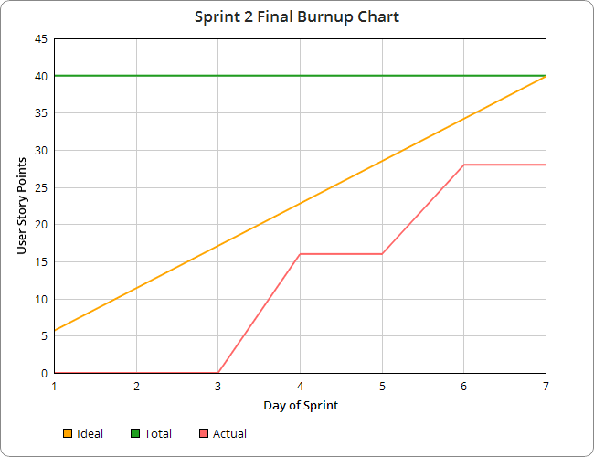

**Work Completion Rate:**

Total number of user stories completed: 2

Total number of estimated ideal work hours completed: 60

Total number of days for the sprint: 7 days

User Stories per day: .5 user story/day

Ideal work hours per day: 10 hr/day